**Christopher King**

**2018141521058**

**Mechanical Design 2**

**Class Section 01**

**09/02/2021**

# **Problem 1**

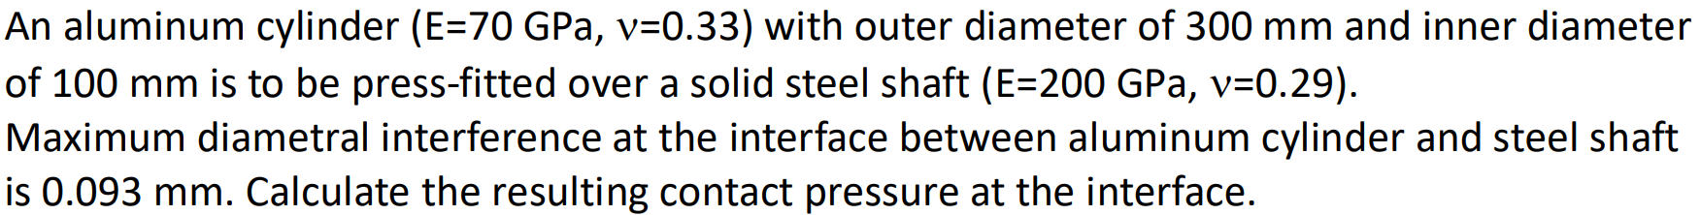

**Solution:**

For this question, we are asked to calculate the resulting contact pressure at the interface.